FREE WAYS TO HELP OUR SCHOOL IN ONE MINUTE OR LESS!
- Link your Harris Teeter VIC card to #1512.
- Use your Partners key fob every time you shop at Publix.
- Use the Shoparoo app to upload grocery and restaurant receipts.
- Link your www.smile.amazon.com account to Matthews Elementary School PTO. Most amazon purchases will give 0.5% back to our school!
- Ordering prints or photo books? Visit http://matthewselementary.shutterflystorefront.com/ and 13% of your purchase will come back to the school!
- When shopping at Office Depot or Office Max, please tell the cashier to link your purchase to Matthews Elementary. We will get 5% back for all purchases. Our school ID is 70061833.
- Visit www.us.coca-cola.com/give/ . The code in a bottle lid is worth 3 cents and the code in a fridge pack is worth 15 cents.
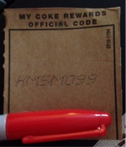
EVERY PENNY COUNTS! Thank you for your support!

